Department of Computer Science and Engineering
Lab Report
Lab Report No | : | 05
Lab Report Name | : | Forward Difference Interpolation
Course Title | : | Numerical Methods Sessional
Course Code | : | CSE 226
Name | : | Fahim Faisal Pathan
ID | : | 1119033
Level | : | 2 | Term | : | 2 | Section | : | A | Group | : | G2
Date of Submission | : |  | Semester | : | Spring | Year | : | 2026

Marking Rubric
Problem Understanding & Report Clarity (3) | Implementation (4) | Results, Analysis & Presentation (3) | Total(10)

Key Learning:
- Learned how to use Newton's Forward Interpolation Method.
- Created difference tables (Δ y, Δ²y, Δ³y).
- Calculated p = (x − x₀) / h.
- Used arrays and loops to simplify calculations.
- Estimated an unknown value between known data points.
- Obtained the interpolated value f(4) = 165.

Codde Input:

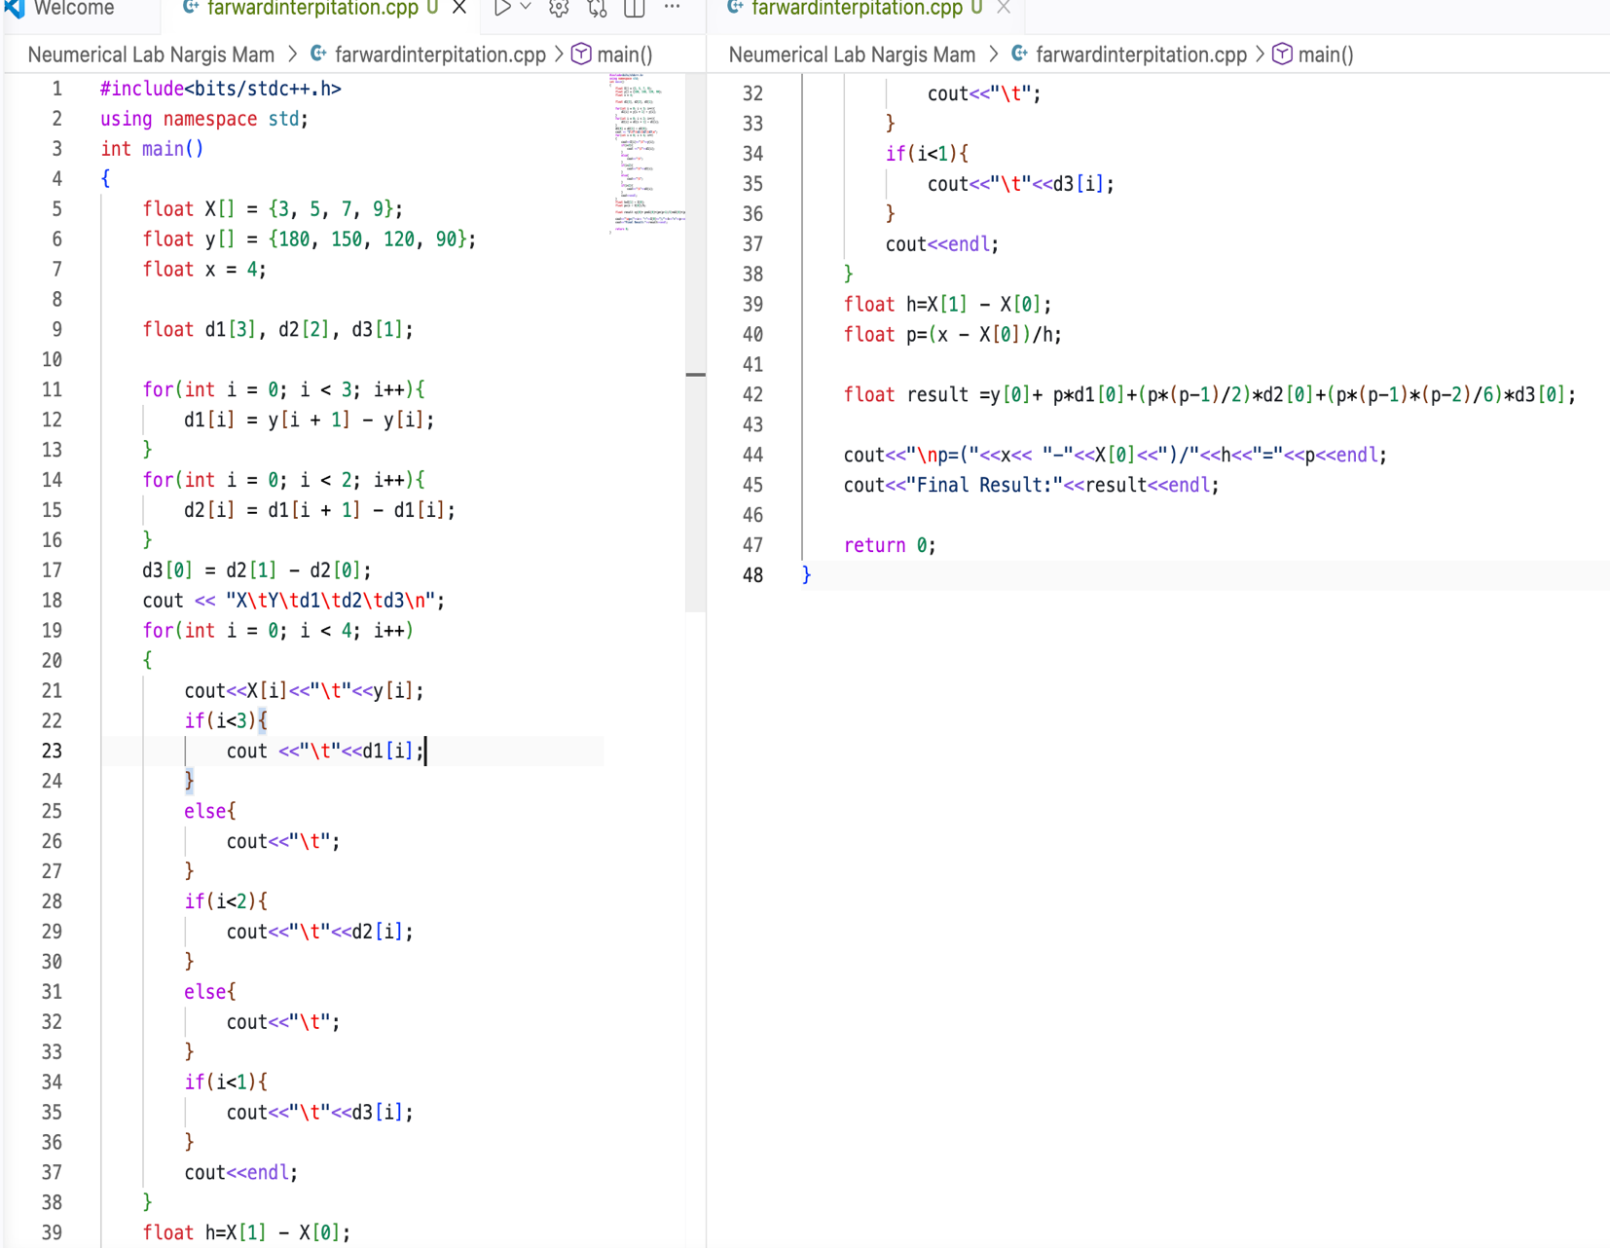

Code Output:
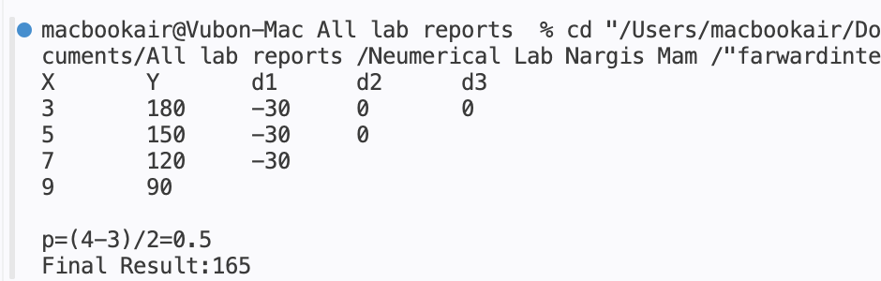

Result Analysis:
The program uses Newton's Forward Interpolation Method to estimate the value of the function at x = 4 from the given data points.
- Given data: (3,180), (5,150), (7,120), (9,90)
- First differences (Δy) are constant: -30, -30, -30
- Since the differences are constant, the data follows a linear pattern.
- The calculated value of p = 0.5.
- The interpolated result is f(4) = 165.

